|  |  |
| --- | --- |
| **Personal Development and Project Planning – CPG 504** | |
| **Group Report, Assignment AE1** | |
| **Tutor:** Peter Jones | |
| **Student Name** | **Student Number** |
| Christopher Youd | Q12376396 |
| Finn Truman | Q12275417 |
| Christopher Pryor | Q12328545 |

# Introduction

The aim of this report is to produce job advertisements for an Indie Game studio who are looking to recruit for 3 roles, these being an Artist, Programmer, Designer or Level Designer.

This project was group based, and upon meeting we decided that we would base our Indie Game Studio in Southampton and there was flexibility within the brief for us to decide what platform to develop for as well as the game engine to use and art style. We decided that we would use Unity as our Game Engine in a 2D capacity. As the game would be developed within Unity there are a number of platforms that it can be ported to.

For this project, we would need to research real life advertisements and base the adds the group creates upon these. As the brief given does not explicitly state the experience level required for the job adverts, a decision was made to aim for graduate positions.

In this report, there are the three job adverts we made as a team, the rationales for each as written by the team member that made the respective advert, a reflection on the project and the appendix containing the adverts we found.

# Job adverts

## Artist Job Profile

**Junior 2D Game Artist**

**Southampton**

**£20,000**

We are a small indie studio based in Southampton that are looking to take a new 2D artist under our wing! We have started a new project under the support of a publisher and are expanding our team. Could you be the one?

As a 2D artist you will work as part of our team creating 2D graphics and sprites based on the description and work done by the design team. You will maintain a high level of professional communication with designers to ensure proper implementation of ideas.

Requirements:

* Experience using Photoshop, entire Adobe Creative Suite is a bonus
* Experience using Unity Engine, particularly for 2D game development
* BA degree in a relevant art/animation field
* Strong portfolio showcasing best samples of game art
* Good communication & team working skills
* Understanding of role within a game studio and the workload associated with the position

The Ideal Candidate:

* Evidence of utilising a variety of tools to create industry standard graphics
* Evidence of contributions to team projects
* Evidence of original design work

If you think you have what it takes and want to be a part of a small friendly team, please email your CV to Chris at hireme@somedomain.com including a link to your portfolio.

**Programmer Job Profile**

**Graduate Unity Gameplay Programmer**

**Southampton**

**£25,000**

We are a small indie studio based in Southampton that are looking to take a new programmer under our wing! We have started a new project under the support of a publisher and are in need of a larger team. Could you be the one?

As a graduate gameplay programmer in an indie studio, you will be working closely with the rest of the team to bring our designers’ game mechanics to life! You will also be responsible for debugging your own code.

Requirements:

* Bachelor’s degree in a relevant field, 2:1 or higher.
* Must have developed one complete game, solo or as part of a team.
* Experience in Unity’s 2D engine, with a minimum one year’s worth of experience in C#.
* Team worker with good communication skills.
* Hardworking and punctual attitude.
* A portfolio of your work.

The Ideal Candidate

* Experience in other programming fields (AI, graphics, tools, etc.).
* Experience in object-oriented design (C++/C#).

If you think you have what it takes and want to be a part of a small friendly team, please email your CV to Finn at hireme@somedomain.com including a link to your portfolio.

## Level Designer Job Profile

**Graduate Level Designer**

**Southampton**

**£18,000**

We are a small indie studio based in Southampton that are looking to recruit a Graduate Level Designer. As a Level Designer, you will be working within a small multi-disciplinary team overseeing both Artists and Programmers, enabling an efficient workflow, learning new skills in friendly and dynamic environment, helping you gain vital skills and experience to become a fully equipped Level Designer.

Everyone on the team is thrilled to be working on a new project with a local publisher. The project will be based on new IP and is due to be released across multiple next-gen platforms.

On top working on a new exciting IP, the company will offer a competitive salary, 22 days’ holiday per annum, increasing with length of service, flexible working hours and company pension scheme.

Requirements:

* Educated to Degree level
* Experience creating levels with Unity, predominantly for 2D game development
* An understanding of C# scripting & Game logic
* Able to accept criticism and find solutions
* Experience creating and updating relevant design documentation
* Able to prioritise workload

The Ideal Candidate

* Experience in multiplayer / co-op games, this can include personal, school and/or game jam prototypes
* Experienced using 3DS Max / Maya for Level Design
* Take existing content and use in new ways

If you think you have what it takes and want to be a part of a small friendly team, please email your CV to Chris at hireme@somedomain.com, including a link to your portfolio.

# Cogent Rationales

## Rationale for Artist

This advert will be primarily hosted on online job sites, primarily job sites focussed on game industry roles such as *amiqus.com,* as this allows it to reach the widest potential number of applicants as these websites are very popular for both experienced games industry workers and new applicants.

Different elements of this advert were designed based on the research conducted. The salary was based on a Junior 3D artist position, and so it was found appropriate to use the same amount. As the advert was designed for junior graduates, requirements such as having industry experience was not necessary, and so focusing on ensuring applicants were experienced in using the software needed to complete work, as well as having general skills that shows they can work in a team. A common occurrence when researching job adverts for artists required applicants to have a portfolio demonstrating their work.

## Rationale for Programmer

For the programming advert, it was decided to advertise it on the website Amiqus.com. This is a commonly used videogame agency. For the salary, research was carried out to find the average for a graduate programmer, which was found to be circa £25,000 (Payscale.com, 2017).

As it is a graduate position, it makes sense to have a requirement for a degree, a 2:1 is respectable, and is the minimum classification that employers expect these days (Sean Coughlan cited in AGR Graduate Recruitment Survey 2010).

Expecting a minimum’s year worth of experience in C# is fair, and the student should’ve earnt this during their time at university. It is also expected of a programmer to be able to debug their own code.

## Rationale for Level Designer

The research carried out for level designer were all sourced from online media, such as, amisqus.com and datascope.com, as this have the ability to reach a much larger audience than that for any other medium i.e. Journal & Magazine prints. As a team, it was discussed we would use amisqus.com to advertise as it is a trusted company for many large and small companies.

The job advert for graduate level designer was based on four positions currently be recruited for buy other companies, however what I did come across was that there no Level Designer jobs specifically advertised for Graduates, so from the researched positions, there were a number of requirements that were common, such as scripting and game flow, exposure to game engines so these were used within the advert created. To get a rough estimate for the salary, research was carried out and found that salaries for a level designer ranged from £18,000 to £26,000 so for a graduate post the minimum value was used, as the graduate may not have any experience should be awarded the minimum found (glassdoor.com, 2017).

# Summary

This report provides analysis of, and creation of 3 job roles, these being Artist, Level Designer and Programmer. The team went for a very plain and simplistic approach to the design of the adverts which give a clean look and is what appears to standard for most roles.

As this was a group project it was discussed the methods used were going to be online sources, as this would reach a larger audience, than that of printed or subscription based media.

What appeared to be a common theme when researching is the lack of jobs tailored for Graduates, however this could be due to the time of year in which searches were carried out.

Since carrying out this report as a group we now have a much better understanding of how indie studios operate, in terms of staffing and each roles responsibility. Research was carried out and one source was able to explain the basics of how to form an Indie Game Development Team, (NYFA, 2014).

## References

COUGHLAN, S, (Cited in AGR Graduate Recruitment Survey 2010) 2010. AGR Graduate Recruitment Survey 2010 [07/07/17]. Available from: http://agr.org.uk

GLASSDOOR.CO.UK, 2017. Level Designer Salaries [07/03/17]. Available from: https://www.glassdoor.co.uk/Salaries/level-designer-salary-SRCH_KO0,14_SDAS.htm

NEW YORK FILM ACADEMY, 2014. How to form a Solid Indie Game Development Team [07/03/17]. Available from: https://www.nyfa.edu/student-resources/forming-solid-indie-game-development-team/

# Appendix

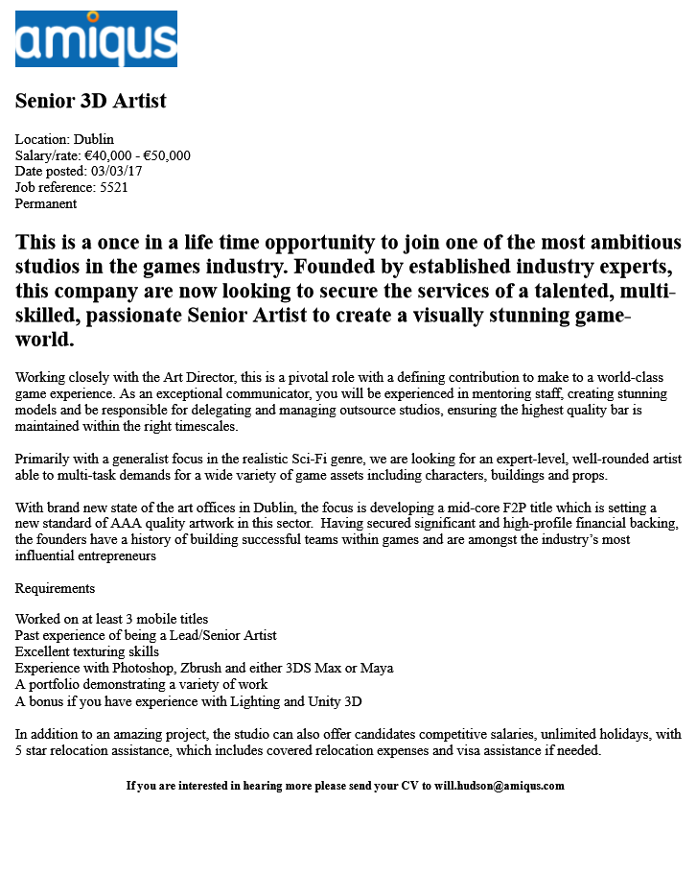

Figure

AMIQUS.COM, 2017. Senior 3D Artist [03/03/17]. Available from: https://www.amiqus.com/job/senior-3d-artist-jobid-5521 accessed on 03/03/17.

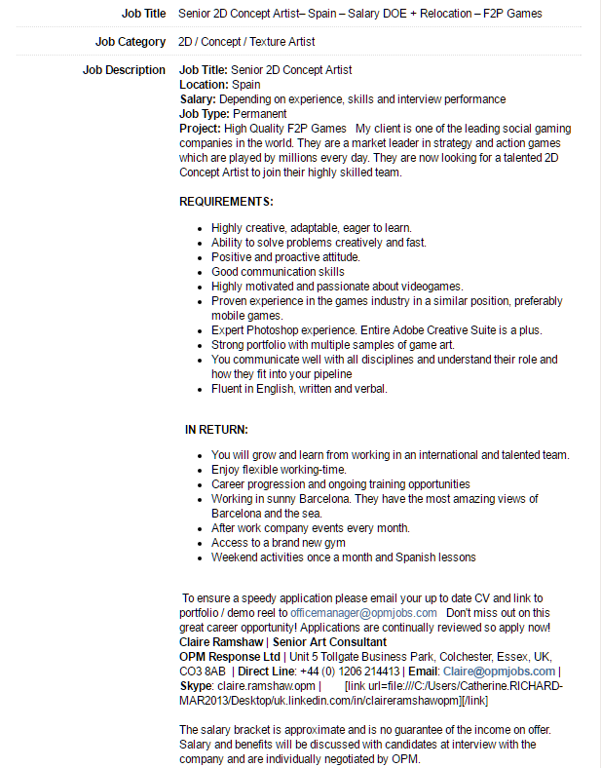

Figure B

OPM JOBS, 2017. Senior 2D Concept Artist [02/03/17]. Available from: http://jobs.gamesindustry.biz/opm/uk-and-europe/senior-2d-concept-artist--spain---salary-doe---relocation---f2p-games-id90177

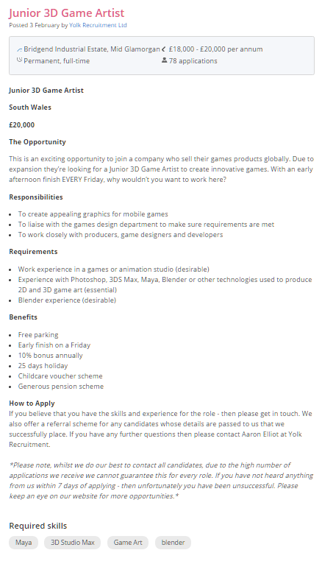

Figure C

REED.CO.UK, 2017. Junior 3D Game Artist. [04/03/17]. Available from: https://www.reed.co.uk/jobs/junior-3d-game-artist/31576059?utm_medium=aggregator&utm_source=glassdoor&utm_term=REG&rx_campaign=glassdoor20&rx_group=101239&rx_job=31576059&rx_source=Glassdoor&rx_medium=cpc

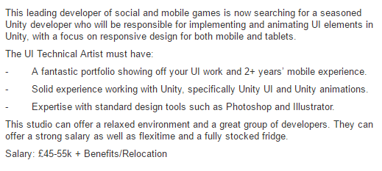

Figure D

DATASCOPE.COM, 2017. UI Technical Artist [04/03/17]. Available from: http://www.datascope.co.uk/job-details/all-games-jobs/art-and-animation-jobs/ui-technical-artist-london-mobile-45-55k-benefits/13353.html

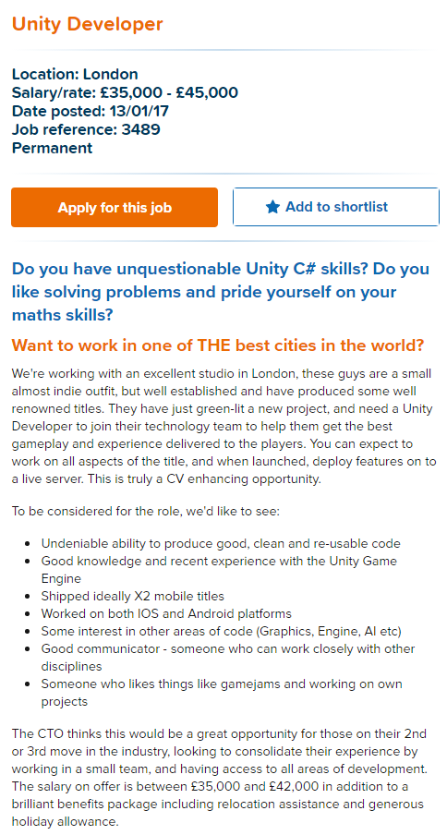

Figure E

Alan, 2017. Unity Developer [07/03/17]. Available from: https://www.amiqus.com/job/unity-developer-jobid-3489



Figure F

Aardvark Swift, 2016. Graduate Programmer [07/03/17]. Available from: http://aswift.com/jobs/graduate-programmer-2/

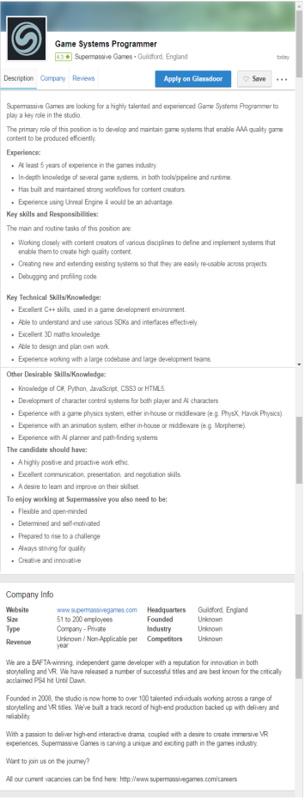

Figure G

Supermassive Games, 2017. Game Systems Programmer [07/03/17]. Available from: https://www.glassdoor.co.uk/Job/southampton-game-programmer-jobs-SRCH_IL.0,11_IC3380757_KO12,27.htm?jl=2296783052

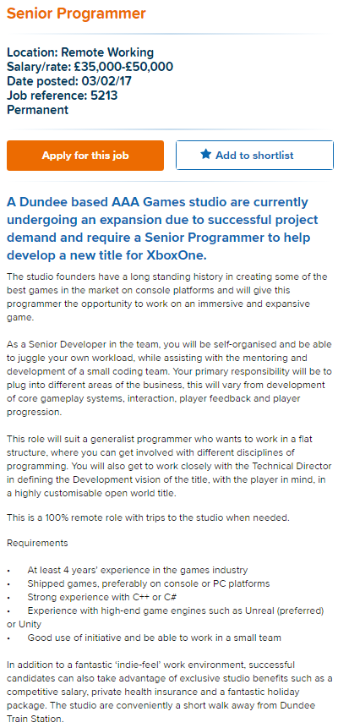

Figure H

Will, 2017. Senior Programmer [07/03/17]. Available from: https://www.amiqus.com/job/senior-programmer-jobid-5213

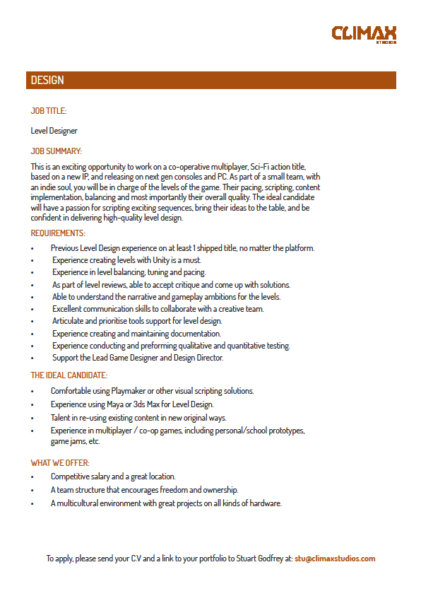

Figure I

CLIMAX STUDIOS, 2017. Level Designer [06/03/17]. Available from: http://www.climaxstudios.com/job_specs/LevelDesigner.pdf



Figure J

DATASCOPE.CO.UK, 2017. Level Designer [07/03/17]. Available from: http://www.datascope.co.uk/job-details/all-games-jobs/games-and-level-design/level-designer-midlands-18-20k/12737.html



Figure K

AMIQUS, 2017. Level Design [07/03/17]. Available from: https://www.amiqus.com/job/level-design-jobid-5574

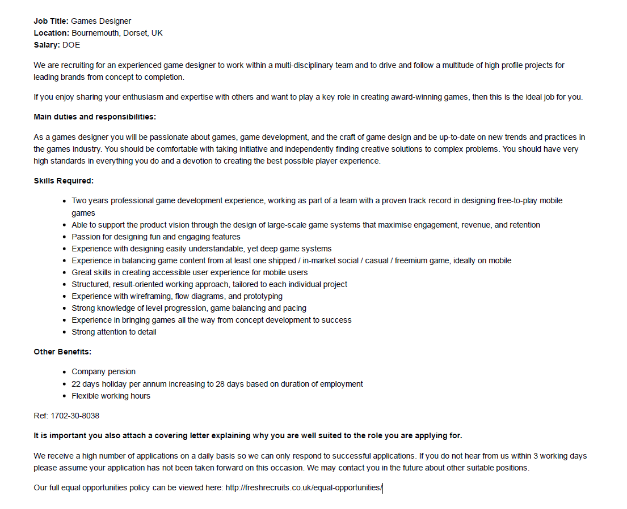

Figure L

TOTAL JOBS, 2017. Games Designer [07/03/17]. Available from: https://www.totaljobs.com/job/games-designer-in/fresh-recruits-ltd-job67971812?WT.mc_id=A_RE_IDPPC_MP1_DSN_11